William Rogers wpr29@nau.edu

LAB 6 REPORT

*PROBLEM*

The goal of this lab is to display a star chart using data from given text files to display the various positions of stars with relative brightness. The second goal is to display an overlay of the constellations given by the various constellation text files.

*SOLUTION*

To accomplish these goals, I will first load the stars.txt file and gather the data into multiple arrays collated into a larger array. I will setup the turtle screen with simple formatting. Then, taking the first two positions for each array, the program should scale the coordinates to fit in the turtle screen. Then, the program will determine the brightness of the star bounded by determined extrema, allowing the turtle to then loop through each and drawing a square of appropriate size. Then, the program will load the constellation files to which it will determine the corresponding coordinates for each. With these coordinates the program will draw lines between each of the sets of the coordinates, creating the constellations.

*IMPLEMENTATION AND TESTING*

One primary issue faced when writing the program is the horrible method of storing the stars of which the constellations are determined. The constellations were stored by the star name, and being that multiple stars had the same name, or parts of the same name, the method to find the correct star was overly complicated. Some of the stars were at the end of the line, causing a hidden “\n” tag to be present, and some contained a semicolon separating alternate names. After trial and error 5/8 of the constellations were able to be shown correctly, although some remained incorrect. I can not determine what is causing the issues for the other 3 constellations, but I am certain it is due to some sort of a formatting issue. The following is the result of running the program with the limited amount of constellations:

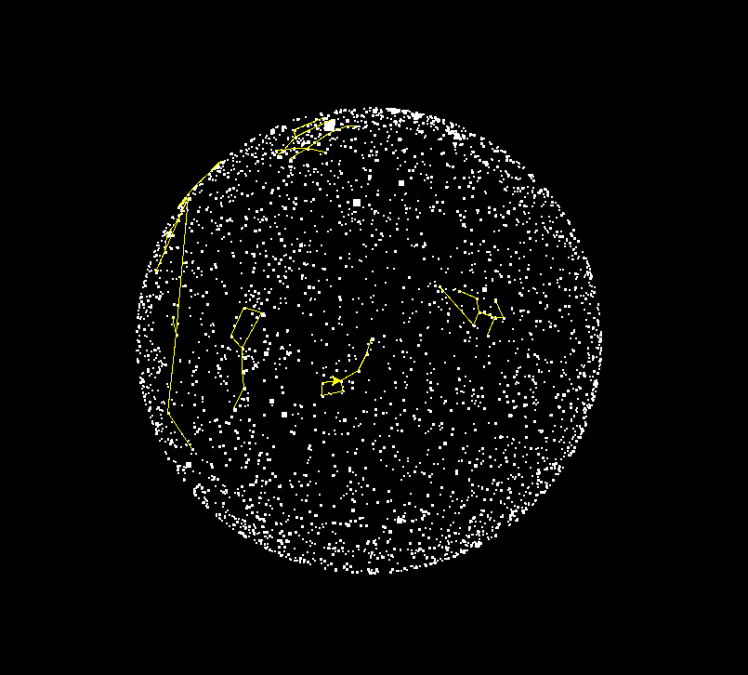

The following shows PEP8 compliance for the program:



*REFLECT AND REFACTOR*

If I were to continue working on this program, I would first remove the extraneous data received from the stars.txt file. I would then determine the name of the star as would be displayed in the constellation files as part of the data loading process, rather than after. This should be able to give me more control over the data coming in, and I hopefully could resolve the issues of nearly duplicate sets of coordinates.